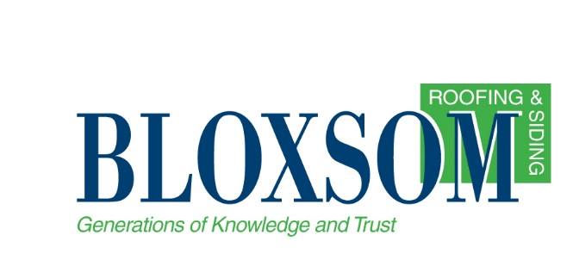

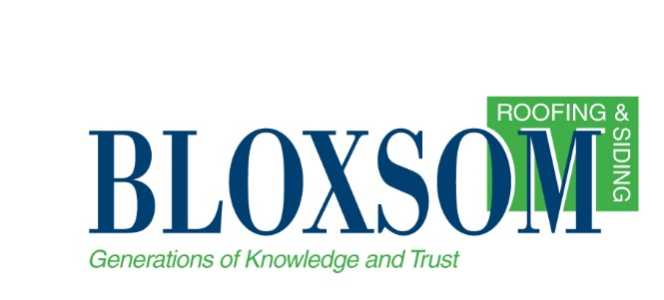

Hazard Communication Program

General

The following hazard communication program has been established.
This program will be available for review by all employees. For Bloxsom Roofing &
Siding Co.

Hazard Classification

Chemical manufacturers or importers shall evaluate chemicals they produced or import to classify the chemicals in accordance with the revised Hazard Communication Standard.

Effective June 1, 2015 - For each chemical, the chemical manufacturer or importer shall determine the hazard classes, and where appropriate, the category of each class that apply to the chemical being classified. This information will be placed in the Material Safety Data Sheet/Safety Data Sheet (MSDS/SDS) and on the product label.

Bloxsom Roofing & Siding Co. will rely on MSDS/SDSs obtained from product suppliers to determine which chemicals are classified as hazardous for employees.

Labeling

  - The Safety Supervisor will be responsible for seeing that all containers entering the workplace from a manufacturer, importer or distributer are properly labeled.

  - All labels shall be checked for:

Current requirements: | Requirements effective June 1, 2015:
- Identity of the material.  - Appropriate hazard warning for the material  - Name and address of the responsible party. (Only if the container is received from the manufacturer, distributor, or importer.) | - Product identifier;  - Signal word;  - Hazard statement(s);  - Pictogram(s);  - Precautionary statement(s); and,  - Name, address, and telephone number of the chemical manufacturer, importer, or other responsible party.

  - Each Job Foreman shall be responsible for ensuring that all secondary containers used in their work area are labeled with the appropriate product identifier and provide employees with the specific information regarding the physical and health hazards of the hazardous chemical.

Note: Workplace labeling. The employer shall ensure that each container of hazardous chemicals in the workplace is labeled, tagged or marked with either:

The information specified for labels on shipped containers; OR, product identifier and words, pictures, symbols, or combination thereof, which provide at least general information regarding the hazards of the chemicals, and which, in conjunction with the other information immediately available to employees under the hazard communication program, will provide employees with the specific information regarding the physical and health hazards of the hazardous chemical.

Safety Data Sheets

Changes to MSDS/SDS format effective June 1, 2015 - Chemical manufacturers or importers shall ensure that MSDS/SDSs for their products includes the following Sections in order:

Section 1, Identification;

Section 2, Hazard(s) identification;

Section 3, Composition/information on ingredients;

Section 4, First-aid measures;

Section 5, Fire-fighting measures;

Section 6, Accidental release measures;

Section 7, Handling and storage;

Section 8, Exposure controls/personal protection;

Section 9, Physical and chemical properties;

Section 10, Stability and reactivity;

Section 11, Toxicological information.

Section 12, Ecological information;

Section 13, Disposal considerations;

Section 14, Transport information;

Section 15, Regulatory information; and

Section 16, Other information, including date of preparation or last revision.

  - The Safety Supervisor will be responsible for compiling and maintaining the master MSDS/SDS file. The file will be kept in/at Office: 3377 Blair Town Hall Rd. Traverse City Mi. 49685.

  - Additional copies of MSDS/SDSs for employee use are in/at Job Work Trailers.

  - MSDS/SDSs will be available for review to all employees during each work shift. Copies will be available upon request to the Safety Supervisor.

  - Posters identifying the person responsible for maintaining MSDS/SDSs and where the MSDS/SDSs are located are posted at Office Lunch Room: 3377 Blair Town Hall Rd. Traverse City Mi. 49685. Posters notifying employees when new or revised MSDS/SDSs are received will be located in the same location(s).

  - If a required MSDS/SDS is not received, the Safety Supervisor shall contact the supplier, in writing, to request the MSDS/SDS. If an MSDS/SDS is not received after two such requests, the Safety Supervisor shall contact the MIOSHA's Construction Safety and Health Division at (517) 284-7680 or General Industry Safety and Health Division (GISHD) at (517) 284-7750, for assistance in obtaining the MSDS/SDS.

The MIOSHA program does not maintain a library of MSDS/SDSs. However, either of the above divisions will assist an employee in obtaining a copy of an MSDS/SDS by contacting the employer or supplier.

Employee Information and Training

  - The Safety Supervisor shall coordinate and maintain records of employee hazard communication training, including attendance rosters.

  - Before their initial work assignment, each new employee will receive hazard communication training. This will include the following information and training:

Information:
- The requirements of the MIOSHA Hazard Communication Standard
- All operations in their work area where hazardous chemicals are present
- Location and availability of the written hazard communication program, the list of hazardous chemicals, and the MSDS/SDS

Training:
- Methods and observations that can be used to detect the presence or release of hazardous chemicals in the work area;
- The physical, health, simple asphyxiation, combustible dust and pyrophoric gas hazards, as well as hazards not otherwise classified, of the chemicals in the work area;
- Measures the employees should take to protect themselves from these hazards;
- Details of the hazard communication program-- including an explanation of the new label elements [product identifier; signal word; hazard statement(s); pictogram(s); and, precautionary statement(s)] on shipped containers and the workplace labeling system used by their employer; the new SDS format/sections; and,
- How employees can obtain and use hazard information

  - The employee shall be informed that:

    - The employer is prohibited from discharging, or discriminating against, an employee who exercises his/her rights to obtain information regarding hazardous chemicals used in the workplace.

    - As an alternative to requesting an MSDS/SDS from the employer, the employee can seek assistance from the MIOSHA Construction Safety and Health Division, at (517) 284-7680, or the MIOSHA General Industry Safety and Health Division at (517) 284-7750, to obtain the desired MSDS/SDS. A sign or MIOSHA poster will be posted with the address and telephone number of the MIOSHA Divisions responsible for such requests.

  - Before any new physical or health hazard is introduced into the workplace, each employee who may be exposed to the substance will be given information in the same manner as during the hazard communication training.

Multi-Employer Worksites -- Informing Contractors

  - If our company exposes any employee of another employer to any hazardous chemicals that we produce, use, or store, the following information will be supplied to that employer:

    - The hazardous chemicals they may encounter.
    - Measures their employees can take to control or eliminate exposure to the hazardous chemicals.
    - The container and pipe labeling system used on-site.
    - Where applicable MSDS/SDSs can be reviewed or obtained.

  - Periodically, our employees may potentially be exposed to hazardous chemicals brought on our site by another employer. When this occurs, we will obtain from that employer information pertaining to the types of chemicals brought on-site, and measures that should be taken to control or eliminate exposure to the chemicals.

  - It is the responsibility of the Safety Supervisor to ensure that such information is provided and/or obtained prior to any services being performed by the off-site employer. To ensure that this is done the following mechanism will be followed: List all method(s) used to ensure the required information is provided or obtained.

Bloxsom Roofing & Siding will obtain a copy of their companies SDS Book

Pipes and Piping Systems

Information on the hazardous contents of pipes and piping systems will be identified by: List means of identification for pipes and piping systems (i.e., label, sign, placard, written operating instructions, process sheet, batch ticket, etc.). Natural gas, steam and compressed air lines (with pressures exceeding 25 psig) must be identified in all industrial facilities. ANSI A13.1-1981 recommends the following colorations: blue for low-medium pressure oxygen and compressed air lines, yellow for variable-high pressure oxygen and compressed air lines, and yellow for acetylene and natural gas lines.

List of Hazardous Chemicals

A list of all hazardous chemicals used by Bloxsom Roofing & Siding Co. is located at the Office: 3377 Blair Town Hall Rd. Traverse City Mi. 49685. Further information regarding any of these chemicals can be obtained by reviewing its respective MSDS/SDS.

Materials which can be purchased by the ordinary household consumer, and which are used for the intended purpose and amount as by the ordinary household consumer, are not required to be included in this list. (It is suggested that you maintain a separate list of all materials you consider to be "consumer use" materials.)

NOTE: This sample program is applicable to most employers in Michigan. The federal OSHA Hazard Communication Standard (29 CFR 1910.1200, effective date May 25, 2012) contains information of particular interest to employers such as retailers, wholesalers, warehouses and employers who work at multiple job sites. All employers are strongly recommended to read the new hazard communication standard to determine its applicability to their workplace. Copies of the standard can be obtained by contacting:

Michigan Department of Licensing and Regulatory Affairs
Michigan Occupational Safety and Health Administration

Management and Technical Services Division
MIOSHA Standards Section (517) 284-7790

Consultation Education and Training Division (517) 284-7720

FREE ONSITE CONSULTATION SERVICE FOR EMPLOYERS

To help employers better understand and voluntarily comply with the MIOSHA Act, free Onsite Consultation programs are available to help small employers Identify and correct potential safety and health hazards

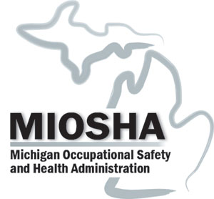

Michigan Occupational Safety & Health Administration
Consultation Education & Training Division
530 W. Allegan Street, P.O. Box 30643
Lansing, Michigan 48909-8143

For further information or to request consultation, education and training services
call (517) 284-7720
or
visit our website at www.michigan.gov/miosha
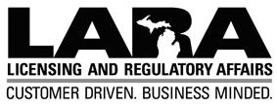

www.michigan.gov/lara

LARA is an equal opportunity employer/program.
Auxiliary aids, services and other reasonable accommodations are available
upon request to individuals with disabilities.

